TASKS ON CLOUDTRAIL AND CLOUDWATCH

1. Enable CloudTrail monitoring and store the events in S3 and CloudWatch log events.

PURPOSE: The purpose of enabling AWS CloudTrail and storing logs in Amazon S3 and Amazon CloudWatch logs is to:
- Track AWS account activity by recording all API calls and user actions performed across AWS services.
- Maintain an audit trail for security, compliance and governance requirements.
- Store logs securely in S3 for longterm retention, backup and forensic investigations.
- Monitor events in real time using CloudWatch logs to detect unauthorized access, configuration changes or suspicious activities.
- Create alerts and notifications through CloudWatch alarms when specific events occurs.
- Troubleshoot operational issues by reviewing historical API activity and resource changes.
- Improve security visibility across AWS resources and user actions.

OBJECTIVE: The objective of this task is to configure AWS CloudTrail to capture and record AWS account activities and deliver the logs to Amazon S3 and Amazon CloudWatch logs for auditing, monitoring, security analysis and compliance purposes.

OUTCOME:
- CloudTrail continuously records AWS account activities.
- Log files are automatically delivered to S3.
- Events are streamed to CloudWatch Logs.
- Administrators can search, analyze, monitor, and receive alerts for important AWS activities.

PREQUISITES:
- An AWS account with administrative permissions.
- An existing S3 bucket (or permission to create one) for storing CloudTrail logs.
- IAM permissions to create CloudTrail trails, CloudWatch log groups, and IAM roles.
- Access to the AWS Management Console.

STEP BY STEP IMPLEMENTATIONS:
- Create S3 bucket to store our logs that have created by using CloudTrail service.

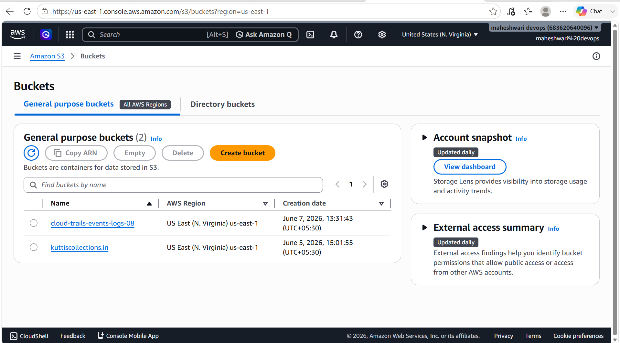

- Now create CloudWatch log group to store our CloudTrail Event logs.
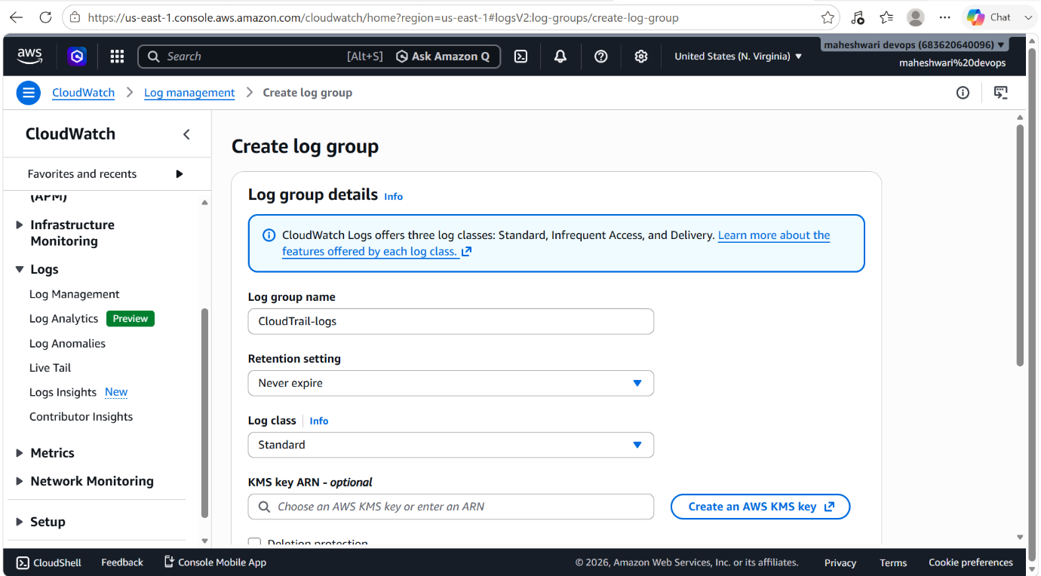
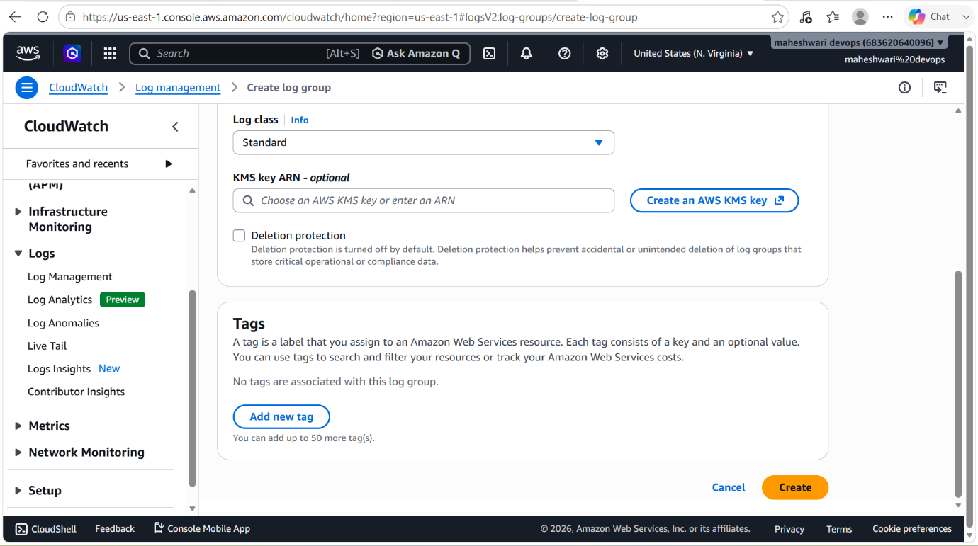

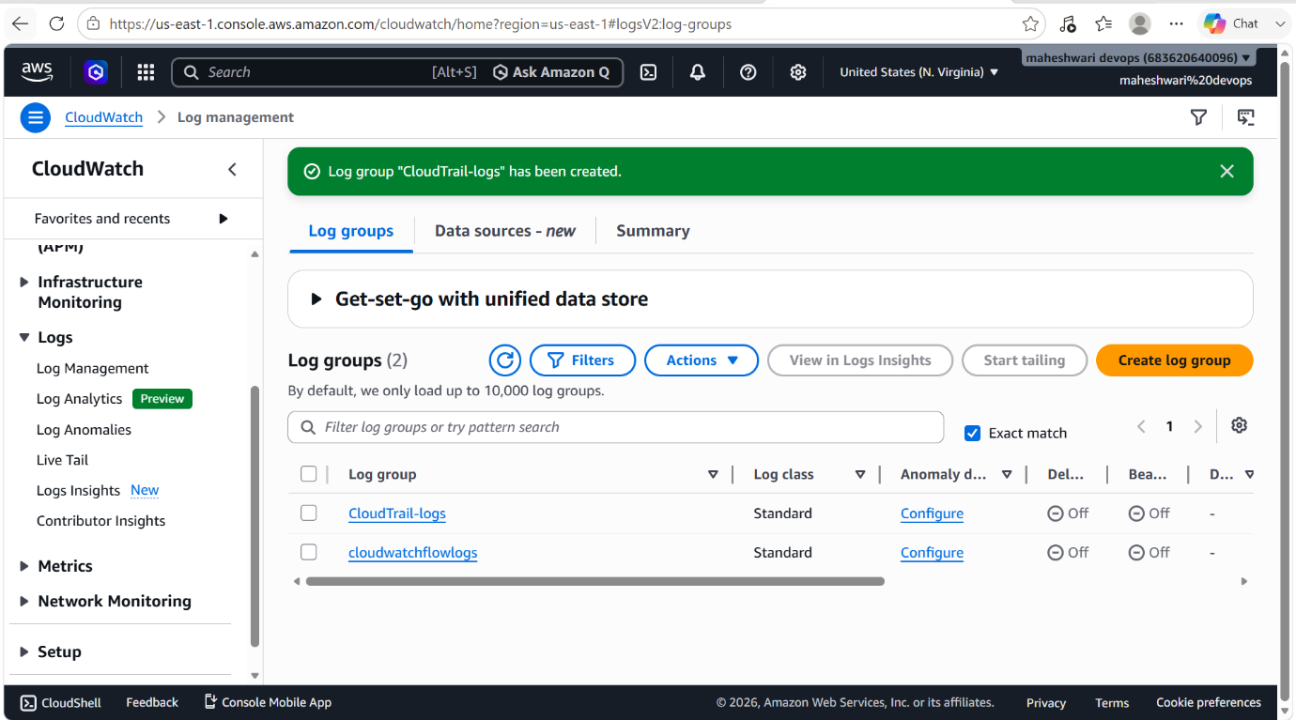

- Create an IAM Role for the CloudTrail.

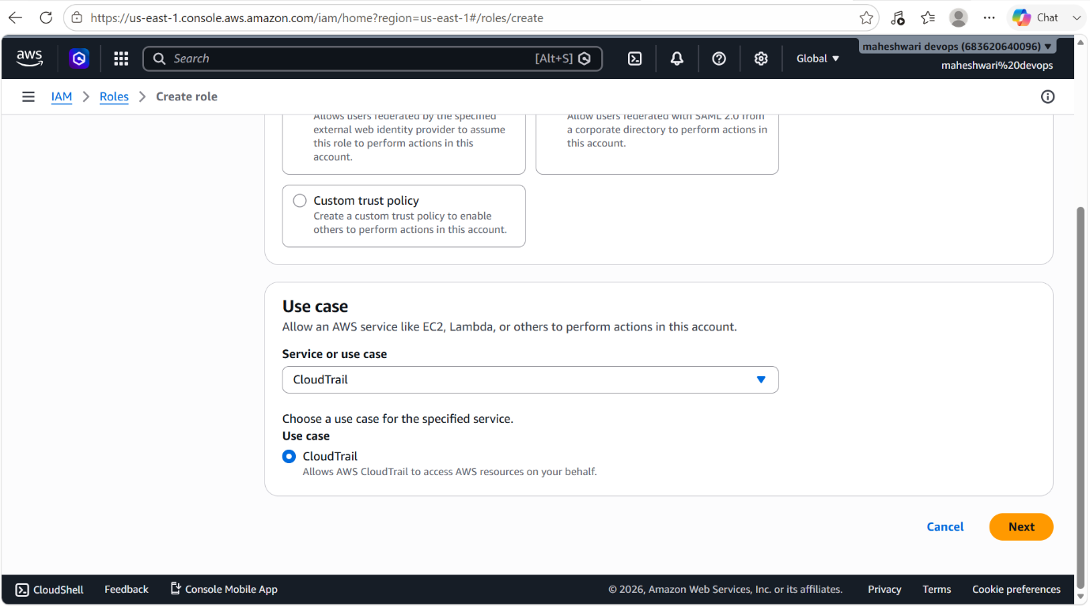

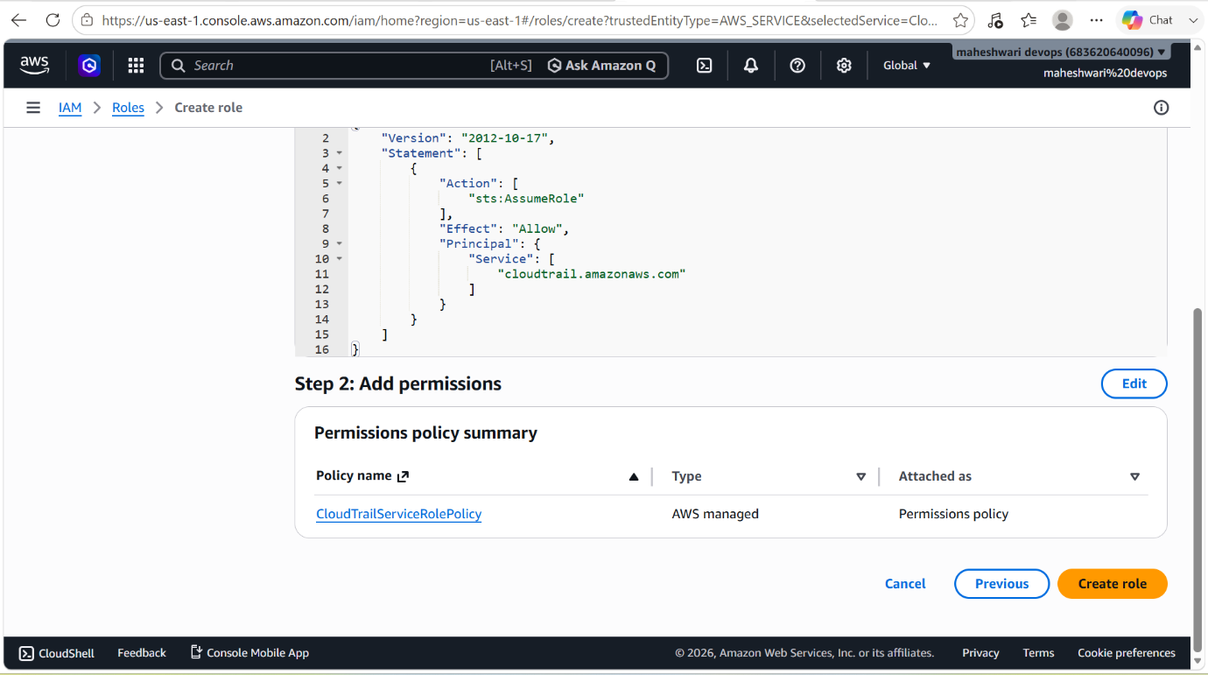

- Now create a CloudTrail Trail and enable for all the regions and under storage location choose existing S3 bucket and click on create.
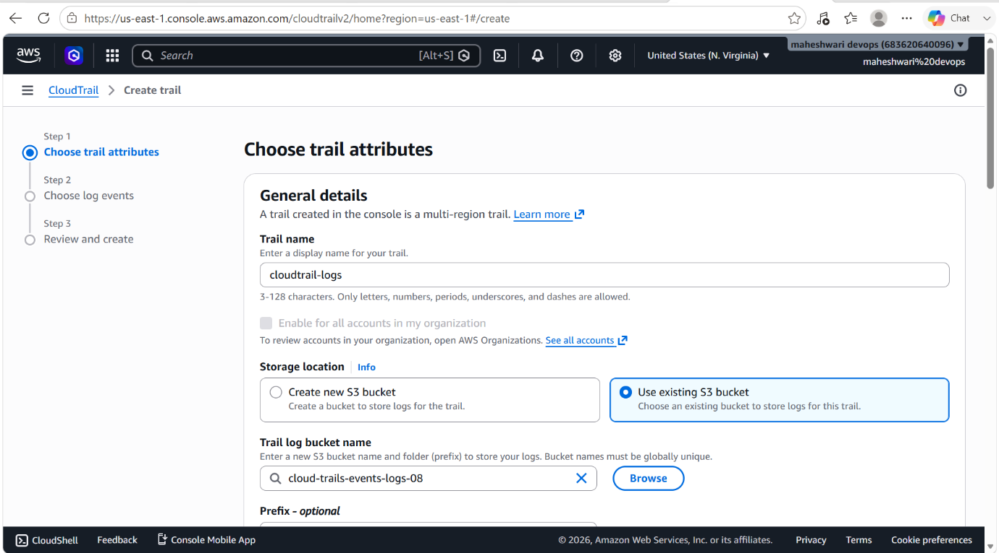
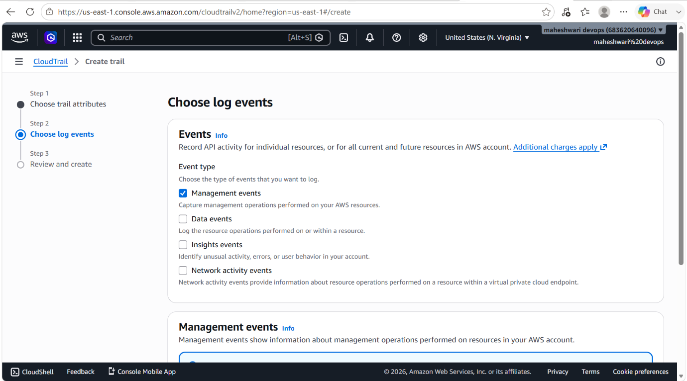

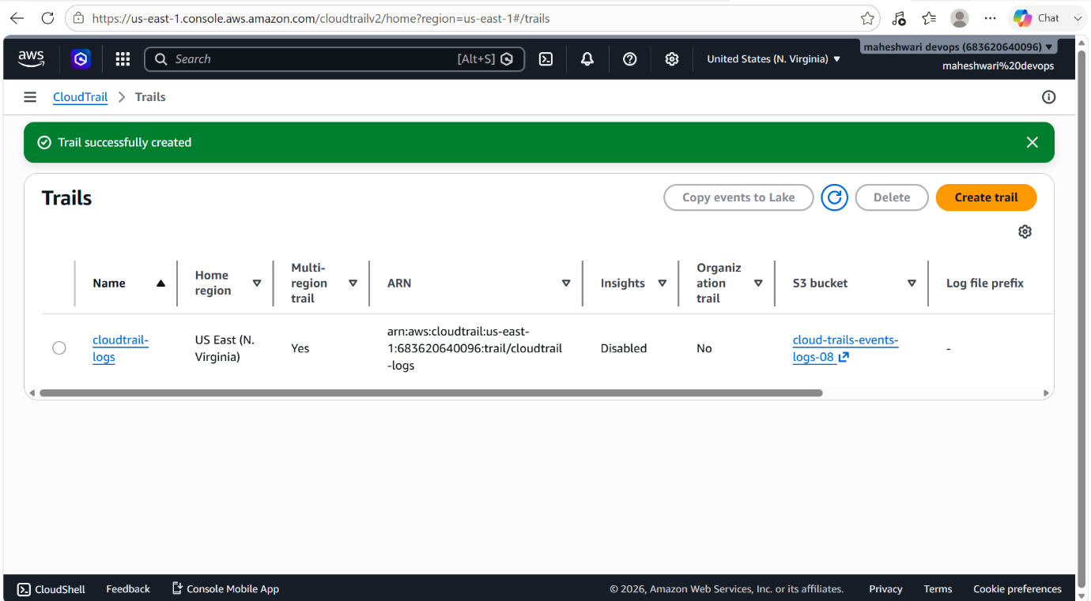

- Now check whether the cloudwatch logs integration and iam role is attached to cloudtrail or not.
- If not then do it manually in cloudtrail.
- Now the complete process to record logs is successfully.
- To verify whether the logs are storing or not, make some changes in the S3 service.
- Now you can see some logs in CloudTrail.

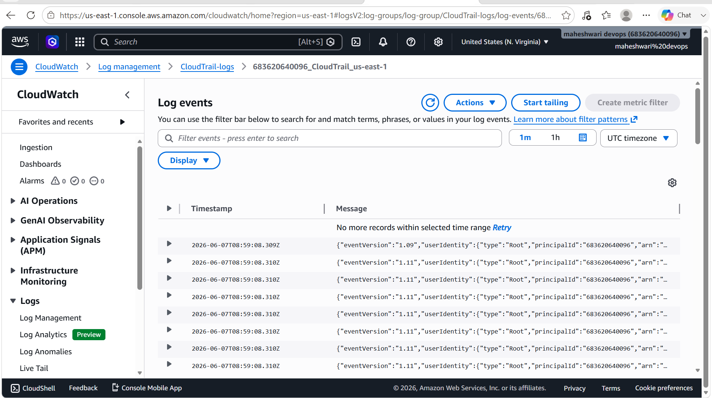

2. Enable SNS for CloudTrail to send alerts via email.

PURPOSE: The purpose of integrating Amazon Simple Notification Service (SNS) with AWS CloudTrail is to provide automated notifications whenever specific CloudTrail events occur, allowing administrators to respond quickly to important account activities and security incidents.

OBJECTIVE: The objective of this task is to integrate AWS CloudTrail with Amazon SNS to automatically notify administrators via email when specific CloudTrail events or AWS account activities occur.

OUTCOME: A real-time alerting system is established where CloudTrail events trigger SNS email notifications, improving security, monitoring, compliance, and operational responsiveness across the AWS environment.

STEP BY STEP IMPLEMENTATION:
- Go to simple notification service in AWS, create a topic by selecting standard option to send an email or message about warning.

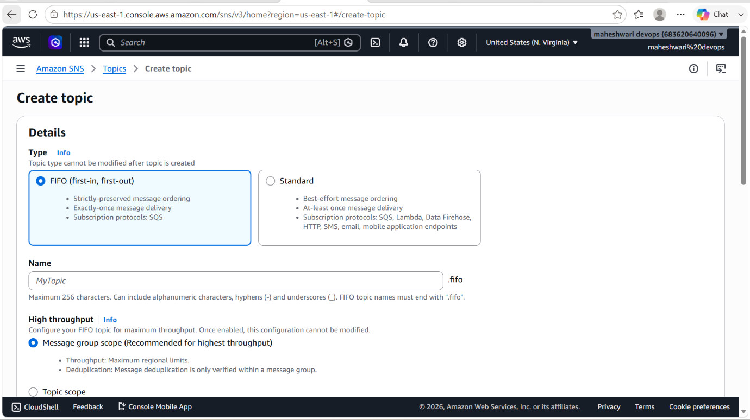

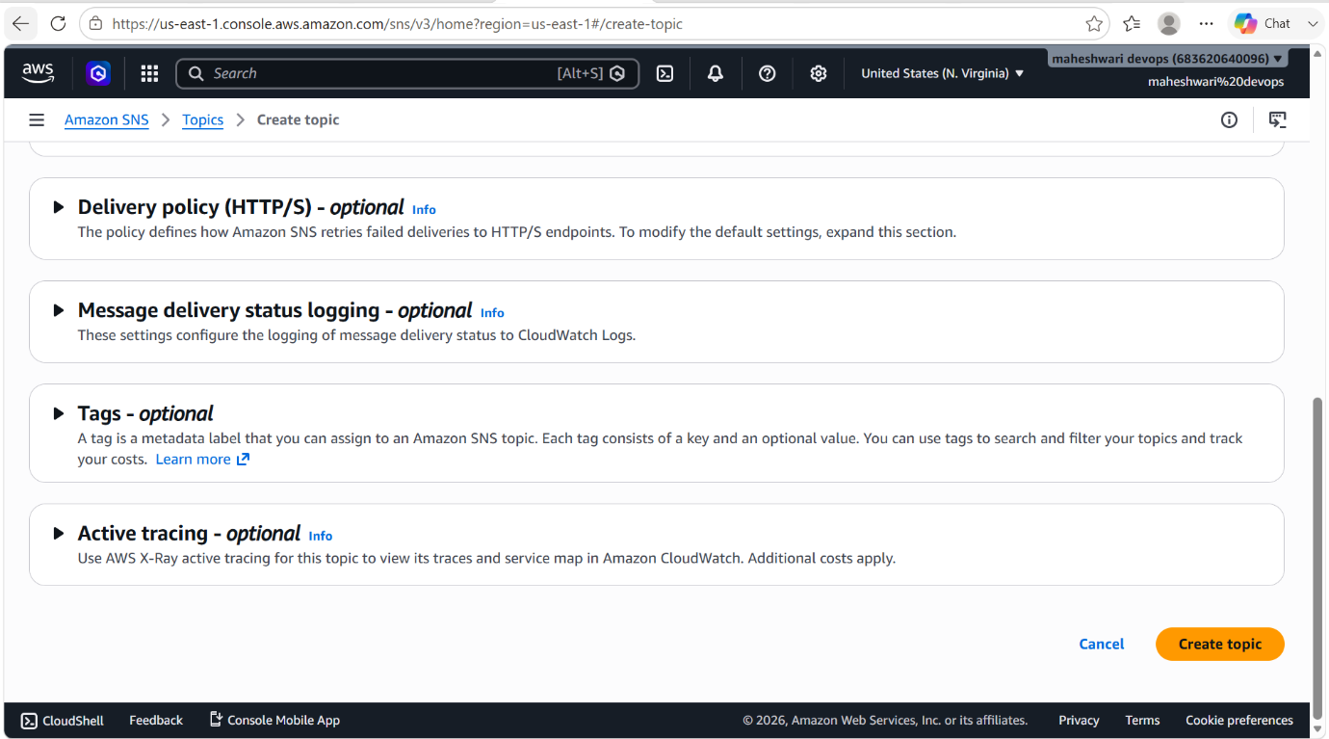

- To enable this SNS in CloudTrail, go to subscriptions in SNS service and create a new subscription that’s where it asks for email or number that in which way you want the notification.

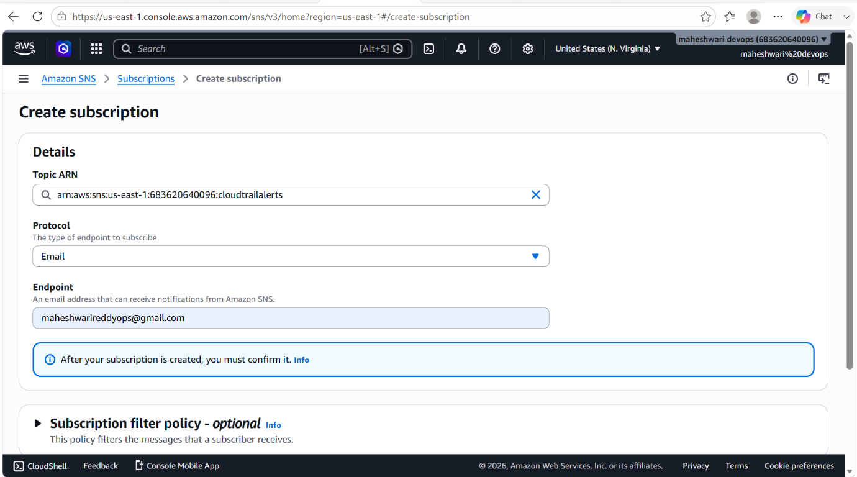

3. Configure CloudWatch monitoring and record the CPU utilization and other metrics of EC2.

PURPOSE: The purpose of configuring Amazon CloudWatch monitoring for Amazon EC2 instances is to continuously collect, monitor, and analyze performance metrics to ensure health, availability and optimal performance of the instances.

OBJECTIVE: The objective of this task is to configure Amazon CloudWatch to collect, store and monitor performance metrics from Amazon EC2 instances, enabling administrators to track system health, resource utilization, and operational performances.

OUTCOME: CloudWatch continuously gathers and records EC2 performance metrics, providing dashboards, graphs, and alarms that help administrators monitor resource utilization, identify issues quickly, and maintain optimal application performance.

STEP BY STEP IMPLEMENTATION:
- Create a new metric with the details of CPU Utilization of an EC2 instance.
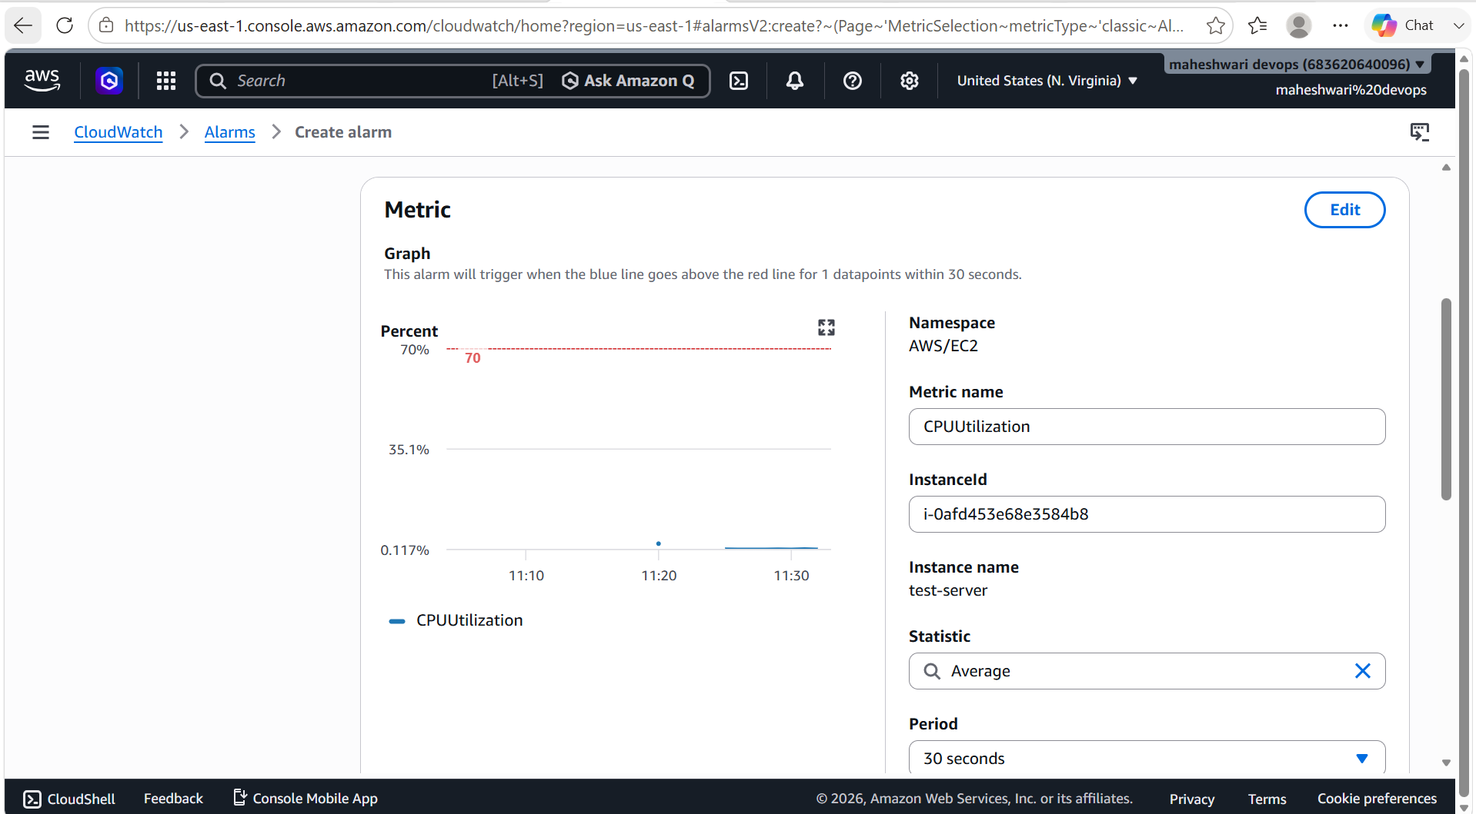

4. Create one alarm to send an alert to email if the CPU utilization is more than 70 percent.
- Go to CloudWatch service of AWS, create a new alarm.
- In the navigation pane, create a new alarm for the CPU Utilization.
- If the CPU Utilization is greater than 70%, then notification send to the user email by using the Simple Notification Service (SNS).

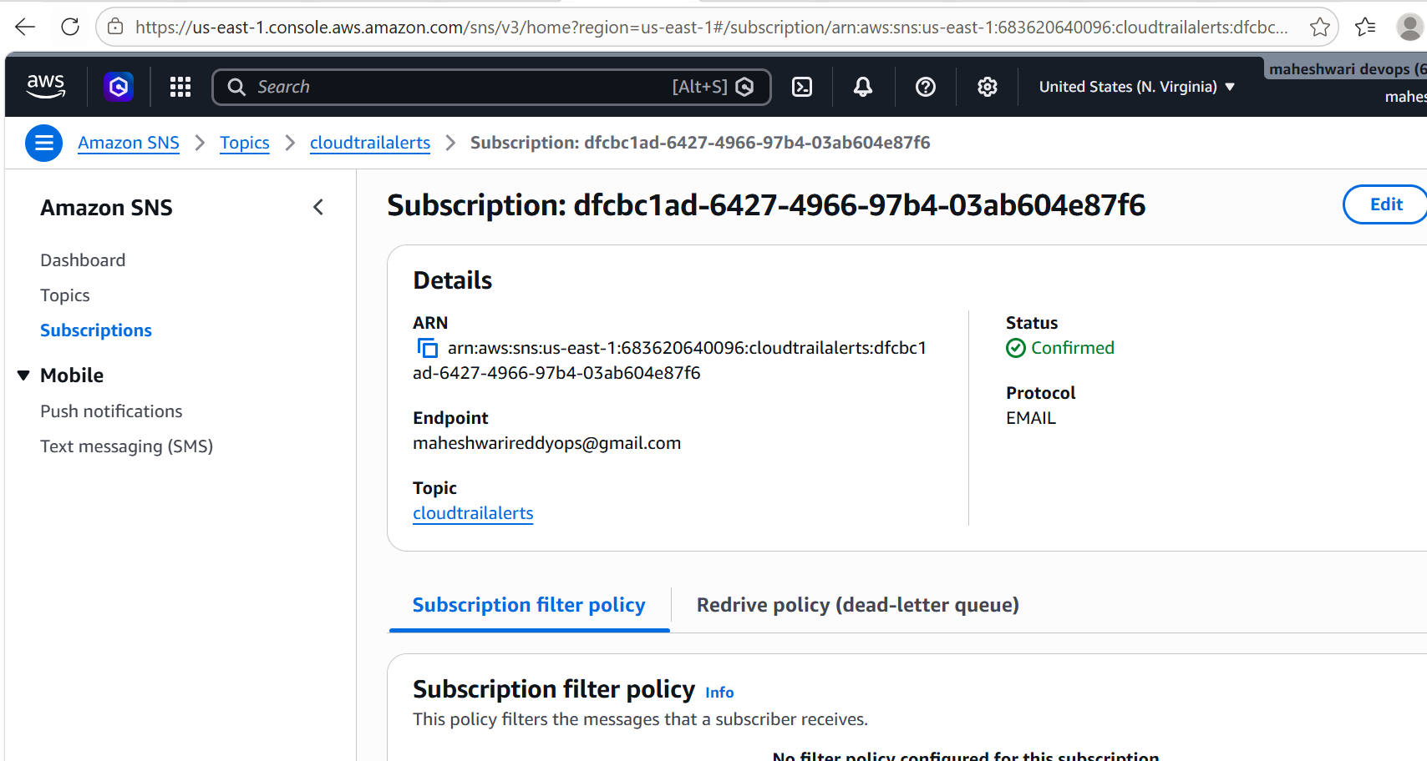
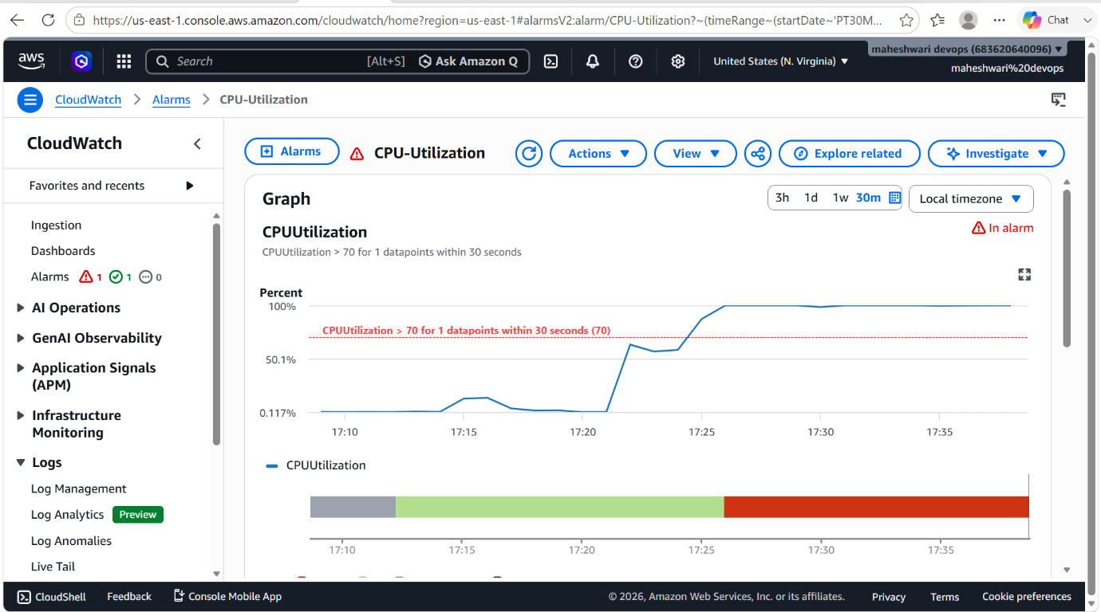

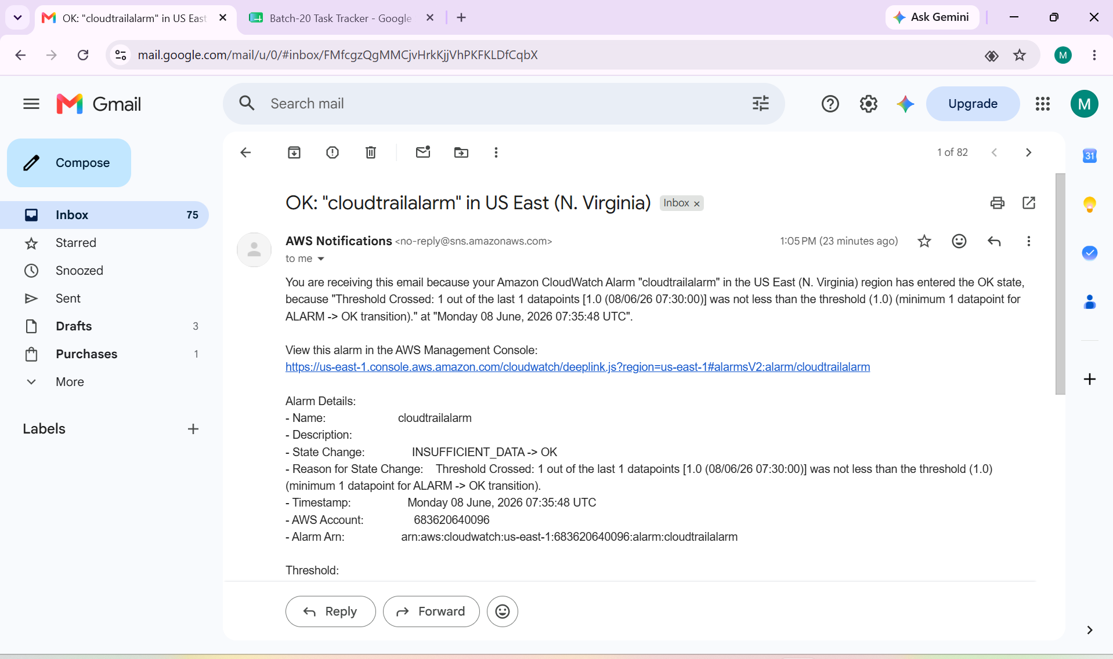

5. Create a Dashboard and monitor the Tomcat service whether it is running or not and send the alert.

PURPOSE: To create a monitoring dashboard that continuously tracks the tomcat service status on an EC2 instance and automatically sends alerts whenever the Tomcat service stops, crashes or becomes unavailable.
OUTCOME:
- A CloudWatch Dashboard displays Tomcat health and EC2 performance metrics.
- Tomcat service status is monitored every minute.
- An SNS email alert is automatically sent when Tomcat stops running.
- Operations teams can quickly identify and resolve service outages, improving application availability.

STEP BY STEP IMPLEMENTATION:
- Launch an EC2 instance and install tomcat in that service.
- Install cloudwatch agent in EC2 instance that you have launched.
- Write a bash script to monitor Tomcat status.
- For that we have create and run the tomcat.service file for systemctl commands execution.
- We have to create cronjob for monitoring Tomcat.
- In AWS account go to cloudwatch service and create a dashboard and also create a alarm for the monitoring of Tomcat service.
- We have to set a threshold for this that, if the threshold is 1 then alarm should be OK and if the threshold is lower than 1 then alarm should be triggered and send a notification to the user email by triggering SNS service.

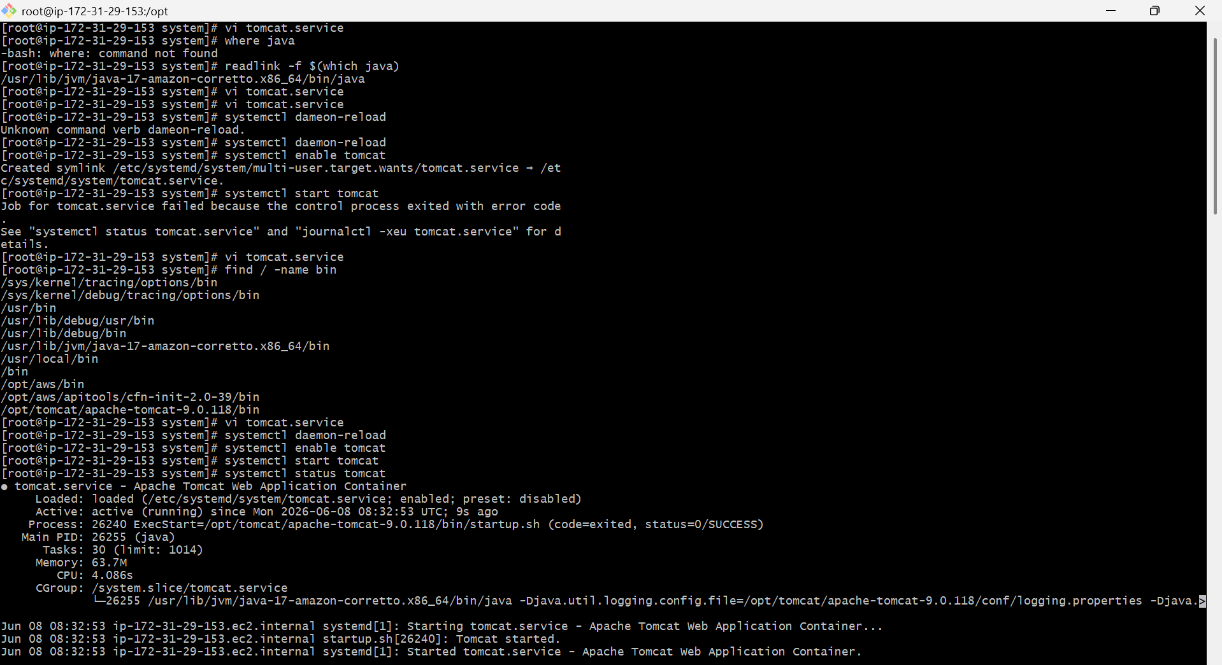

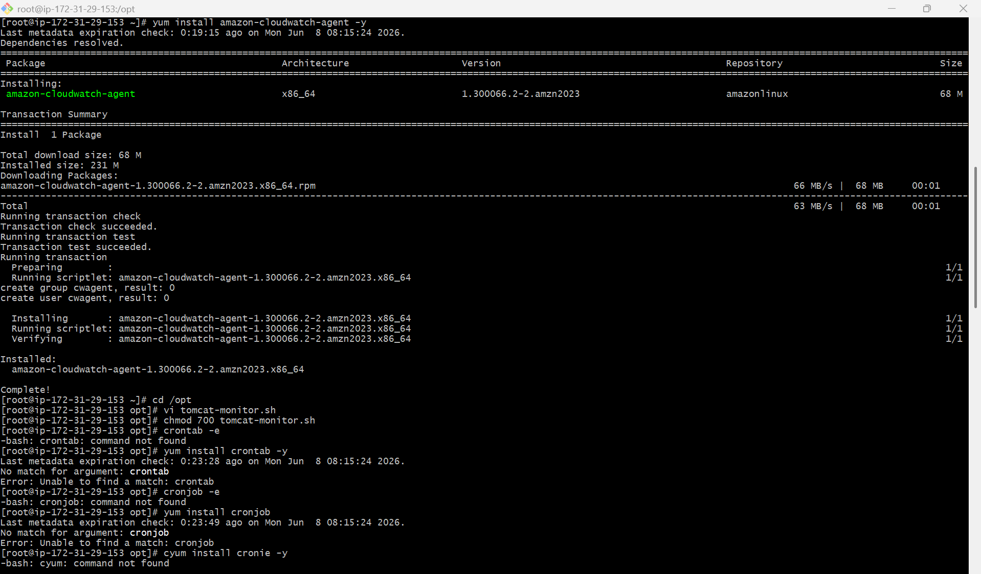

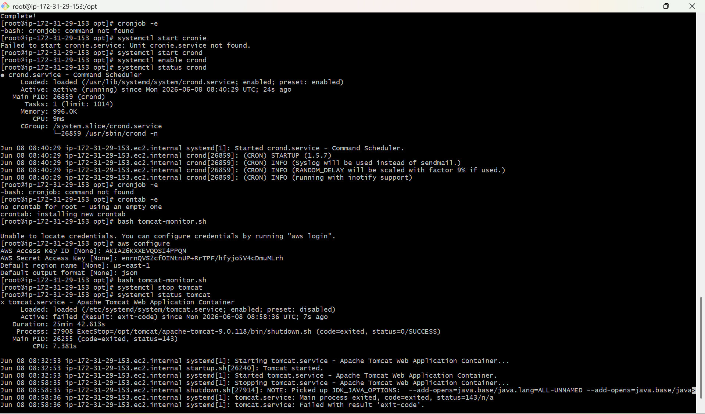

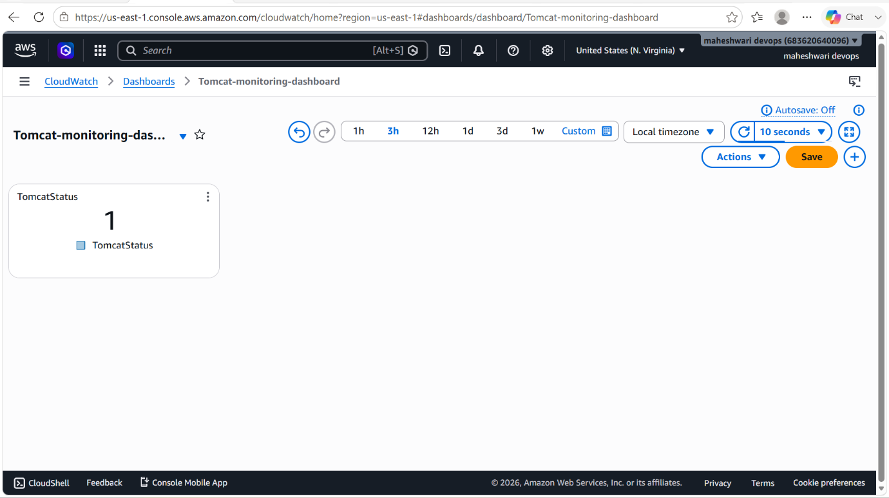

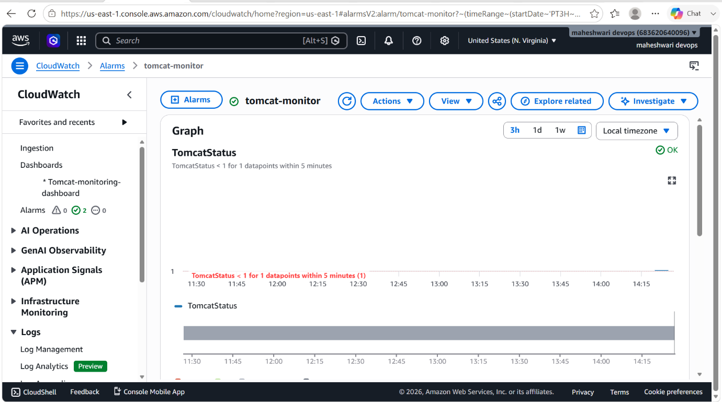

- To verify whether ALARM is working as mentioned or not, stop the tomcat service and check the alarm.

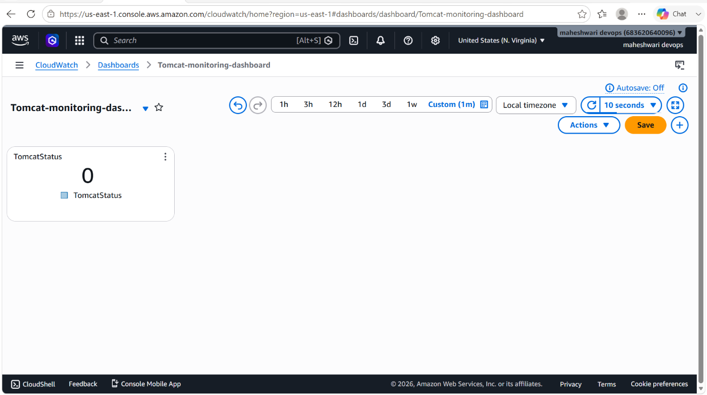

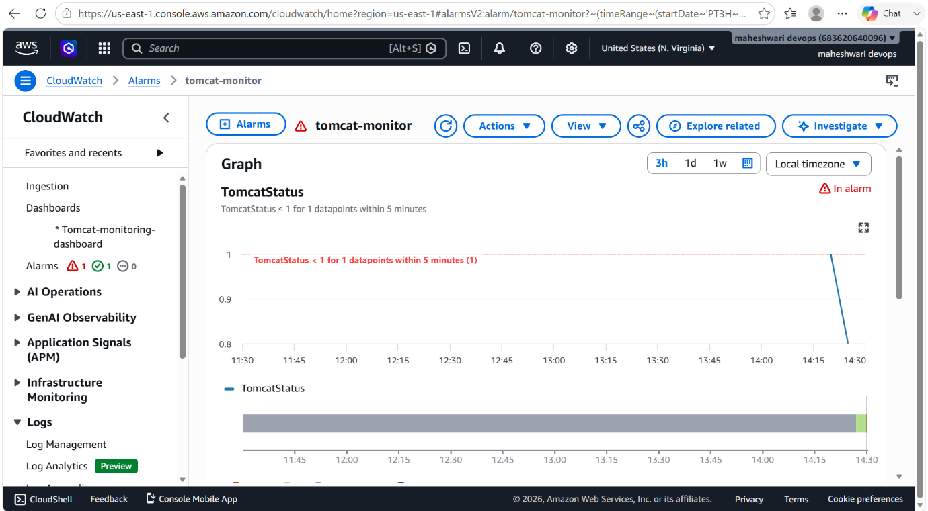

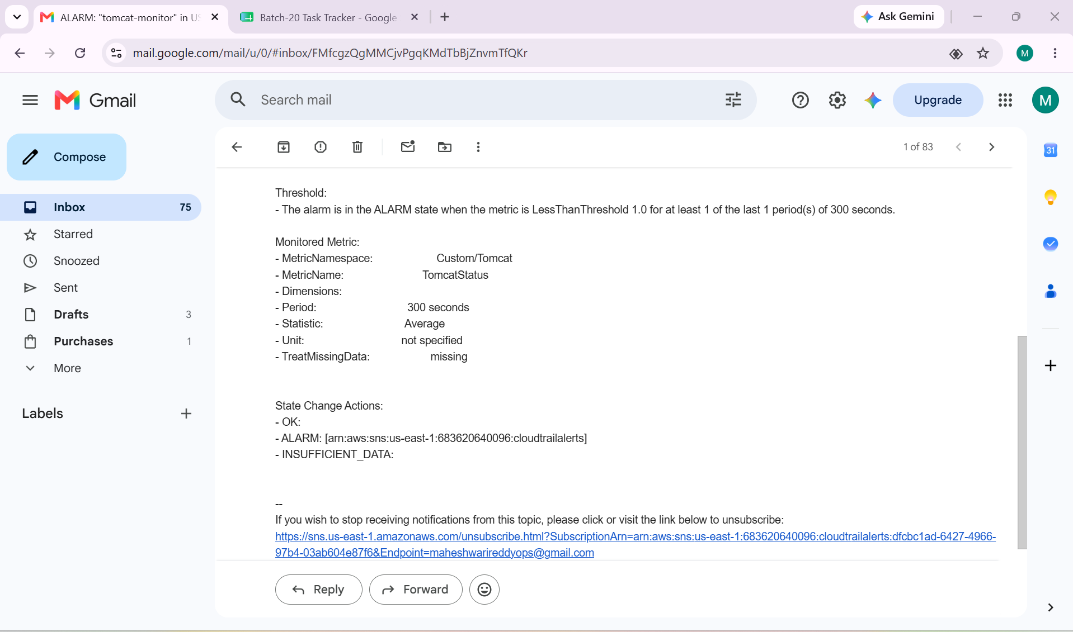

6. Create a Dashboard and monitor the Nginx service to send the alert if Nginx is not running.

OBJECTIVE: To monitor the Nginx service running on an EC2 instance, visualize its status in a CloudWatch Dashboard, and automatically send alerts when the Nginx service stops or becomes unavailable.

OUTCOME:
- A CloudWatch Dashboard displays Nginx service health and EC2 metrics.
- Nginx status is checked every minute.
- Custom metric Nginx Status reports:
-> 1 = Running
-> 0 = Stopped
- CloudWatch Alarm detects service outages.
- SNS sends email alerts whenever Nginx is not running.

STEP BY STEP IMPLEMENTATION:

- Create an EC2 instance and download Nginx service.
- Download cloudwatch agent to push the metrics related to nginx server status.
- Then write a script to check the status of server and send the metrics to the cloudwatch.
- We have to set a threshold for this that, if the threshold is 1 then alarm should be OK and if the threshold is lower than 1 then alarm should be triggered and send a notification to the user email by triggering SNS service.

